INDIAN INSTITUTE OF MINERAL ENGINEERS
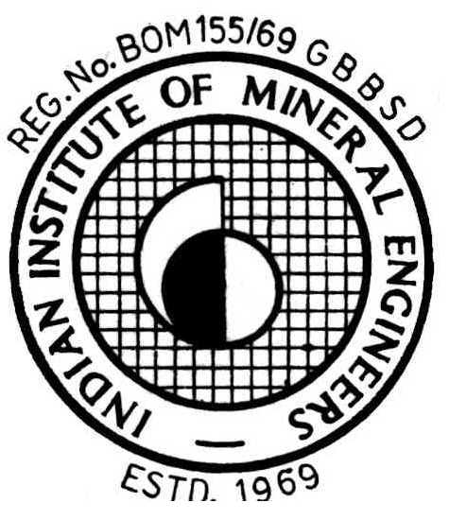
(Registration No. Bom 155/69 G.B.B.S.D.)
C/o Mineral Processing Division
National Metallurgical Laboratory

Jamshedpur - 831 007

Dr. Manoj K. Mohanta No. IIME-HQ /2019/SEC/AW-1
Hony. Secretary, IIME & Date : 24th September, 2019
Senior Principal Scientist, CSIR-NML

Call for Nominations:

INDIAN INSTITUTE OF MINERAL ENGINEERS AWARDS – 2018

To recognise the contributions made by individuals in the field of Mineral and Coal Processing, IIME has instituted the following awards which are presented during its General Body Meeting.

(i) IIME Mineral/Coal Beneficiation Award : Academic/R&D, for the R&D and/or academic contributions made by the nominee in the field of mineral and/or coal Beneficiation. The award is presented in the form of a plaque.

(ii) IIME Mineral/Coal Beneficiation Award : Industrial Practice, for the nominee's contributions to plant practice in the field of mineral and/or coal beneficiation. The award is presented in the form of a plaque.

(iv) IIME Best Paper Awards: These awards are for the Best Papers published, one in each of the following areas, during the calendar year 2017 in any National or International Journals by Indians working in India:

(a) Mineral Processing (b) Ore Characterisation
(c) Electro- Hydro- & Bio-processing, (d) Environment Issues Related to Mineral Processing

Nominations in eight (08) copies are invited for the IIME Mineral/Coal Beneficiation Award in the prescribed format as given below. Self nomination with reprints (published papers) in eight (08) number of copies is invited for IIME Best Paper Awards. The nominations may please be sent in the following address to reach the IIME Secretariat no later than 10th October, 2019:

Dr. M. K. Mohanta
Hony. Secretary,
Indian Institute of Mineral Engineers
C/o Mineral Processing Division
CSIR-National Metallurgical Laboratory
Jamshedpur 831007 (Jharkand)
Email: iime.secy@gmail.com, mkm3.nml@gmail.com

The awards will be presented during the next Technical Convention & General Body Meeting of IIME to be held at Hyderabad on 16th December, 2019.

With kind regards,

(Dr. M.K. Mohanta)

Phone :(0657) 2345054, 2349003, 2345055 Fax : (0657)2345055, 2345213; Website : www.iimeindia.com
E-mail: iime.secy@gmail.com, mkm3.nml@gmail.com, rkrath2010@gmail.com

INDIAN INSTITUTE OF MINERAL ENGINEERS

IIME MINERAL/COAL BENEFICIATION AWARDS -2017

Instructions for Nomination

- Nomination for IIME Mineral and Coal Beneficiation (R&D/ Academic and Industrial Practices) can be made by IIME Executive Council Members, former Presidents and Vice-Presidents of IIME, Patrons of IIME, Chapters of IIME, and Heads of Organisations/Institutions while individual author can directly submit nomination for the best paper awards under different categories.

- The nominee should be an Indian National residing in India and his work meriting nomination should mostly be carried out in India.

- A person can be nominated only for one of the two IIME awards.

- Nomination should be made as per the proforma attached. Separate sheets may be used wherever required.

- IIME Mineral/Coal Beneficiation Award : Academic R&D will essentially be based on R&D and/or Academic contributions made by the nominee in the field of Mineral/Coal Beneficiation.

- IIME Mineral/Coal Beneficiation Award : Industrial Practices will be based on the contributions made by the nominee in significantly improving the ongoing plant practices/intiating new practices/designing of equipment, etc.

- IIME Best Paper Awards: A self-Nomination with 08 copies of article can be sent with the mention of its citation and citation index of the jounal, if any.

- Eight copies of the nomination must reach The Secretary, Indian Institute of Mineral Engineers C/o Mineral Processing Division, CSIR-National Metallurgical Laboratory, P.O.- Jamshedpur- 831007 (Jharkhand) latest by the date 10th October, 2019.

9. Nominations not having eight copies and /or received after the deadline will not be considered.

INDIAN INSTITUTE OF MINERAL ENGINEERS
Confidential
Proforma for Nomination

IIME MINERAL/COAL BENEFICIATION AWARDS - 2018
___________________________________________________________________________________

- Nomination for Mineral/Coal Beneficiation Awards : □ Academic/ R&D
(strike off whichever is not applicable) : □ Industrial Practices

2. Name of Sponsoring Organisation /Person Nominating :
with Ph. No. & Email ID
3. Name of the person nominated / Nominee :
with address, Ph. No. & Email ID
4. Designation, affiliation and address of Nominee :

5. Date & Place of Birth of Nominee:

6. Educational Qualifications (in chronological order) :
College/University/Institute Degree Major Subjects Year

- Professional Experience (in chronological order) :

- Publications
- Technical papers published in referred journals/ Conference proceedings with complete details
including the names of co-authors
(ii) Books/Monographs

- Membership of Professional/Academic bodies :

- Awards & Honours received :

- Contribution towards the growth of IIME :

12. Specific achievements in the Mineral/Coal Beneficiation
field during the last ten years (Please state here in about
300 words meriting this nomination) :

13. Citation of the nominee not exceeding 100 words that reflect nominee's excellence :

14. Names of two persons who are familiar with the work
and achievements of the applicant to whom a
confidential reference can be made to access the
value of the achievement.

(Please attach separate sheets wherever required)

(Signature of the Sponsor)
-----------------------------------------------------------------------------------------------------------------------------------------

Eight copies of Nominations to reach :
Dr. M.K. Mohanta, Hony. Secretary,
Indian Institute of Mineral Engineers
C/o MNP Division
CSIR-National Metallurgical Laboratory
Jamshedpur - 831 007 ( Jharkhand )
FAX . 0657 – 2345055, 2345213
Email: iime.secy@gmail.com
Submission date: Latest by 10th October, 2019.

